Design Document : Neural Accelerator for RISCV

Abstract:
The Neural and ML Accelerator is a custom ASIC accelerator designed for low-power, high-throughput convolutional neural network (CNN) inference at the edge. It features a 32-bit RISC-V management core, a systolic array for matrix multiplication, and dedicated on-chip memory to minimize off-chip DRAM traffic.
In addition to the matrix acceleration engine, the architecture integrates multiple hardware modules commonly required during neural network forward-pass processing, such as activation, pooling, normalization, accumulation units. The accelerator follows a modular instruction-set-based architecture and pipeline inspired by the principles of RISC-V, where different compute modules are selectively multiplexed and controlled through configurable instructions.
As a dedicated edge-processing accelerator chip, the design is optimized to execute machine learning workloads with significantly lower latency and power consumption compared to general-purpose processors. By performing computations locally on-device, the accelerator enables faster real-time inference for applications such as computer vision, autonomous systems, IoT devices, robotics, and intelligent sensing without relying heavily on cloud connectivity.
Key Features
- 32-bit RISC-V inspired instruction architecture
- Modular opcode-driven execution engine
- 3-stage pipelined datapath
- Dedicated 8×8 systolic array
- INT8 computation with 32-bit accumulation
- Edge-AI optimized low-power architecture
- Support for neural-network activation and quantization modules

Architecture:
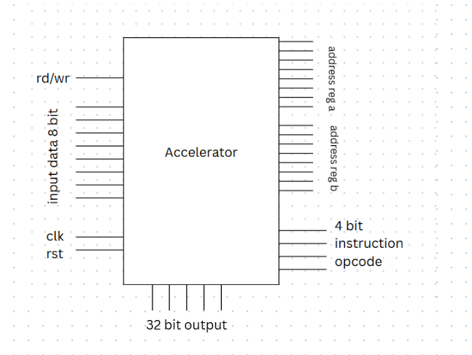
- Instruction Architecture
The instruction format contains:
Field | Purpose
rd/wr | Read or write operation
addr_A | Base address for Matrix A
addr_B | Base address for Matrix B
opcode | Select operation
clk | Clock signal
rst | Reset signal
data_in | Input data during write mode
Control and Interface Signals
The accelerator is controlled using a simple instruction-based interface containing the following signals:
- rd/wr bit
  - Controls load/store operation
  - 0 → Read/Execute mode
  - 1 → Write mode
- 8-bit Register A Address (addr_A)
  - Selects starting address of Matrix A registers
- 8-bit Register B Address (addr_B)
  - Selects starting address of Matrix B registers
- 4-bit Instruction Opcode
  - Supports 16 unique instructions
  - Selects the operation module to execute
- clk signal
  - System clock for synchronous operation
- rst signal
  - Resets registers and internal states
- 8-bit Data Input (data_in)
  - Used during write/load operation to store values into registers
- 32-bit Output (cout)
  - Outputs final computation result from accumulator registers
Working Principle
- The opcode selects the required compute module
- A multiplexer routes inputs and outputs to the selected execution block
- Only the required hardware module becomes active for execution

- Memory Architecture : Register Bank Structure
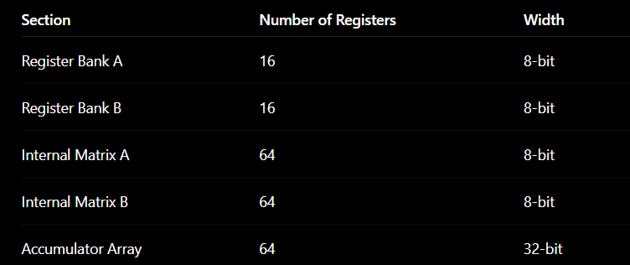
Register Bank A :Stores a 4×4 Matrix A
Register Bank B : Stores a 4×4 Matrix B
The matrices are formed using consecutive register locations.
Example:
- If addr_A = X
  - Matrix element A[0][0] → Register X
  - A[0][1] → Register X+1
  - A[0][2] → Register X+2
  - and so on...
The same method is used for Matrix B.
This matrix construction happens during the Instruction Decode Stage.
Internal Computation Registers
Padded Matrix Registers
This is a new approach to build a padded matrix to reduce the design complexity by constructing a padded matrix for better timing synchronization.
For internal processing:
- Two separate 8×8 register arrays are used
- Each register is 8 bits
- Used for:
  - Matrix padding
  - Parallel computation
  - Alignment with systolic processing structure
These internal arrays temporarily store processed versions of Matrix A and Matrix B before execution.
8×8 Accumulator Array
- Stores intermediate multiplication and accumulation results
- Each accumulator register is 32 bits wide
- Prevents overflow during large computations
The final 4×4 result matrix is connected to the cout output line through wired connections from the accumulator registers.

Microarchitecture ,Datapath ,Control Unit:
The proposed Neural and ML Accelerator follows a modular microarchitecture consisting of a control unit, Datapath, execution engine, register banks, and a 3-stage pipelined processing structure. The architecture is designed for efficient neural-network feedforward computation and systolic-array-based parallel execution.
Overall FSM Control
This FSM enables synchronization between the processor and accelerator while providing execution status monitoring. The accelerator operates using a finite state machine (FSM) containing three primary states:
- IDLE : Default waiting state , Waits for instruction and control signals
- COMPUTE : Busy flag is asserted (busy = 1), Instruction execution and systolic computation occur in this stage
- DONE : Indicates completion of execution, Processor can read the output/result status from the accelerator

3-Stage Pipeline Architecture
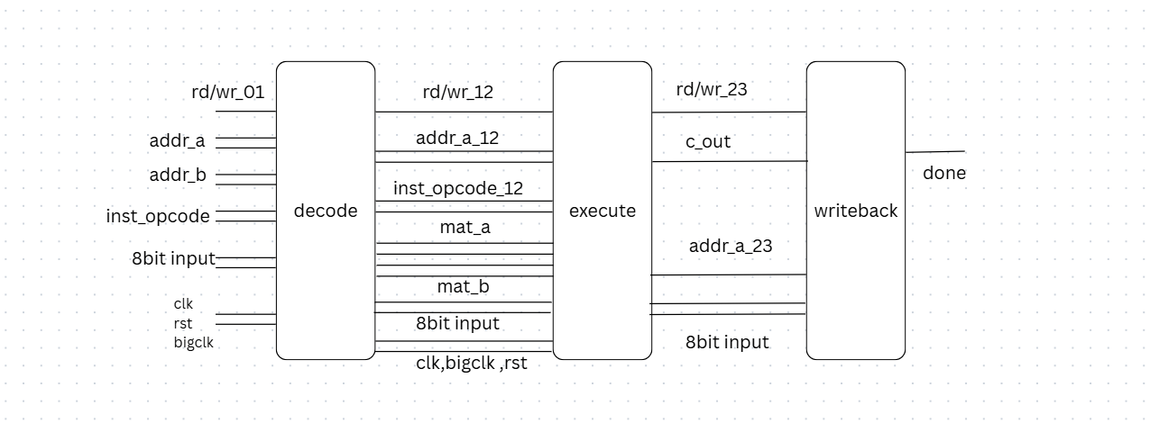
The Datapath is organized into a 3-stage pipeline:
Stage 1 — Data Decode Stage
In the decode stage, register-bank access is performed.
Operations performed in this stage include:
- Reading Register Bank A and Register Bank B
- Constructing matrices using consecutive memory locations
For matrix operations:
- mem[addr_A] → A[0][0]
- mem[addr_A + 1] → A[0][1]
- and similarly for the remaining matrix elements
The same mechanism is used for Matrix B.
For operations requiring only a single register operand:
- Only A[0][0] or the first required register value is taken in the execution stage
For array-based operations:
- The entire row/vector (A[0]) is extracted in the execution stage
The decode stage also forwards opcode ,matrix data ,addresses ,control signals ,clock/reset signals to the execution pipeline stage.

Stage 2 — Execute Stage
The execute stage contains the main computation engine and instruction execution modules. The instruction opcode is routed through a multiplexer structure implemented using the case construct in Verilog. Depending on the opcode, the corresponding execution module becomes active. The architecture currently supports 16 dedicated instruction modules for:
- matrix operations
- neural-network processing operations
- systolic-array-based execution
Two clock domains are used:
- clk : Used for systolic data movement and PE shifting operations
- bigclk : Used for pipeline-level instruction execution, Generated internally using a counter
Since the systolic array requires 8 clock cycles to complete computation, bigclk is generated using: (bigclk = ~bigclk ) after every 8 clk pulses through counter-based clock division logic. This allows synchronization between systolic computation latency and instruction execution timing.

Stage 3 — Write-Back Stage
The final stage performs memory update and output write-back operations. Functions of this stage include:
- Writing c_out back into: register banks ,intermediate registers
- Handling external write operations :
If the write signal is enabled: mem[addr_A] = input_data; can be performed directly to store external data into the register bank.
The write-back stage also generates: completion signal ,done status ,output forwarding
for processor-level synchronization.

Datapath Structure
The datapath consists of:
- Register Bank A
- Register Bank B
- Matrix construction logic
- Instruction decoder
- Multiplexer-based execution selector
- 16 execution modules
- Systolic computation array
- Accumulator array
- Write-back routing logic
The datapath is optimized for:
- parallel execution
- low-latency matrix computation
- reduced memory access overhead
- efficient edge-AI inference

Current Implementation Status
Currently:
- The execution block and instruction modules are fully implemented
- Decode logic, FSM control, and write-back stages are architecturally defined and partially ideated
The modular pipeline-based design allows scalability and future integration of additional ML operations while maintaining compatibility with the instruction-driven accelerator architecture inspired by RISC-V principles.

Execution block:

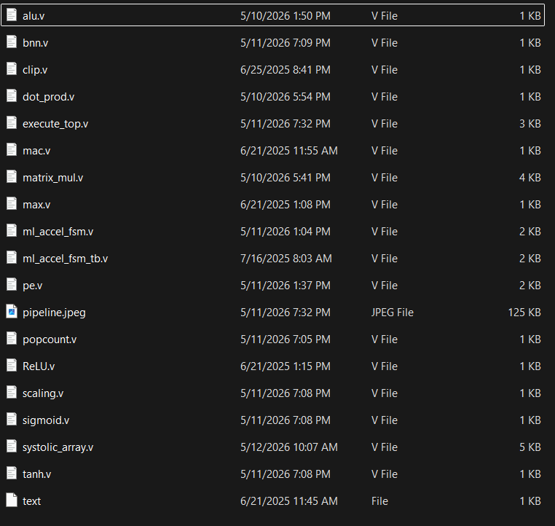
The execution block forms the main computation engine of the accelerator and is responsible for performing neural-network and machine-learning operations selected through the instruction opcode. The module follows a modular execution architecture where each operation is implemented as an independent hardware block and selected using opcode-based multiplexing. The execute stage operates as the second stage of the 3-stage pipeline and receives decoded data, matrix inputs, control signals, and register operands from the decode stage.
The execution block uses two clock domains. Since the systolic array requires 8 clock cycles for computation completion, bigclk is generated internally using a counter-driven clock division mechanism.
Inputs to Execute Block
- reg_a and reg_b for scalar operations
- matrix_a and matrix_b for matrix operations
- opcode for instruction selection
- addr_a and addr_b for pipeline forwarding
- clk, bigclk, and rst control signals
Outputs
- cout : 32-bit execution result
- Forwarded pipeline control signals:
  - addr_a_next
  - addr_b_next
  - rd_wr_bar_next

Execution Modules
The execution engine currently contains multiple dedicated hardware modules commonly required during neural-network forward-pass computation. Single register input modules are:
ReLU Module
- Implements Rectified Linear Unit activation
- Outputs zero for negative inputs
MAC Module
- Performs signed INT8 multiply-and-accumulate operation
- Used for neural-network accumulation and convolution computation
Dot Product Module
- Computes vector dot product using parallel MAC units
- Used in matrix multiplication and feedforward operations
Popcount Module
- Counts number of active bits in an 8-bit input
- Useful in binary neural network computation
Clip Module
- Restricts outputs within programmable minimum and maximum ranges
- Used for quantized inference control
Scaling Module
- Performs fixed-point scaling and shift operations
- Used during quantization and normalization
Sigmoid Approximation Module
- Implements low-cost sigmoid activation approximation
- Optimized for hardware-efficient inference
Tanh Approximation Module
- Provides approximate hyperbolic tangent activation function
Max Finder Module
- Finds maximum value and corresponding index from multiple inputs
- Useful for classification and pooling operations
BNN Module
- Binarized Neural Networks (BNNs) are highly efficient neural networks where weights and activations are constrained to binary values, typically -1 or +1. By replacing standard 32-bit floating-point operations with XNOR and bit-count operations, BNNs drastically reduce memory usage and increase inference speed, making them ideal for edge devices and IoT applications
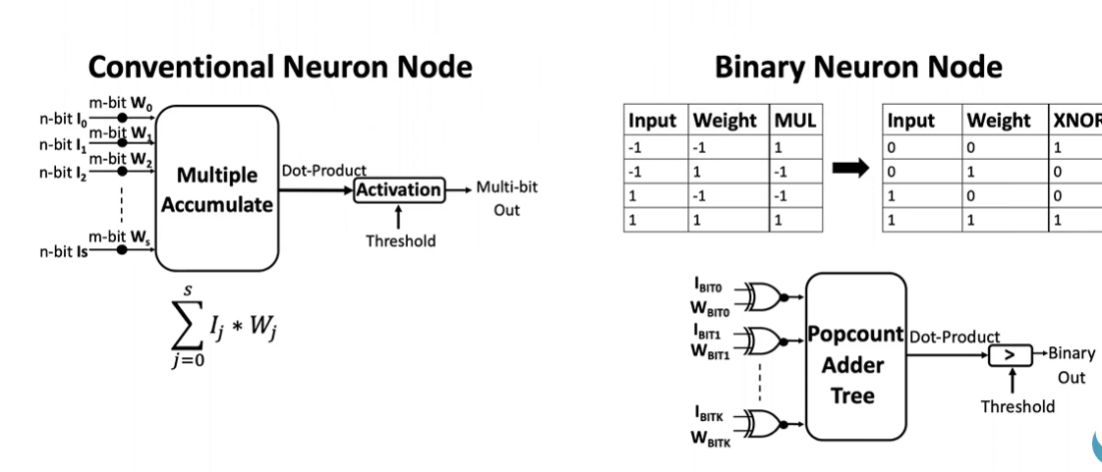
Matrix Multiplication Module
The accelerator includes a dedicated 4×4 matrix multiplication module designed for neural-network and feedforward computations. The module accepts two signed INT8 matrices and generates a 32-bit output matrix. It is controlled using clk, rst, valid, and done signals. Input matrices are latched and Matrix B is transposed for efficient access. Parallel dot_product_4 modules compute matrix elements simultaneously. Results are written into the output matrix and the done signal is asserted.
Dot Product and MAC Modules
The dot_product_4 module computes vector dot products using four parallel int8_mac units. Each MAC unit performs signed INT8 multiplication and accumulation to generate 32-bit outputs. These modules form the basic computation blocks for matrix multiplication and neural-network arithmetic operations.
Systolic Array Module
The accelerator contains an 8×8 systolic array optimized for parallel matrix computation. Internally, 4×4 input matrices are padded into 8×8 arrays for synchronized systolic data movement and timing alignment.
The systolic array consists of:
- Padding logic (a_pad, b_pad)
- Processing Element (PE) grid
- 8×8 accumulator array
- Dataflow routing network – Facilitated by the PE logic
Processing Element (PE)
The Processing Element is the core compute unit of the systolic array.
Each PE performs:
- Input data latching
- Multiply-and-Accumulate (MAC) operation
- Horizontal and vertical data forwarding
Partial sums are stored in accumulator registers and propagated through the array during systolic execution.
Accumulator Array : An internal 8×8 accumulator array stores intermediate 32-bit partial sums generated during matrix computation. The final active 4×4 results are forwarded to the output matrix c_out.
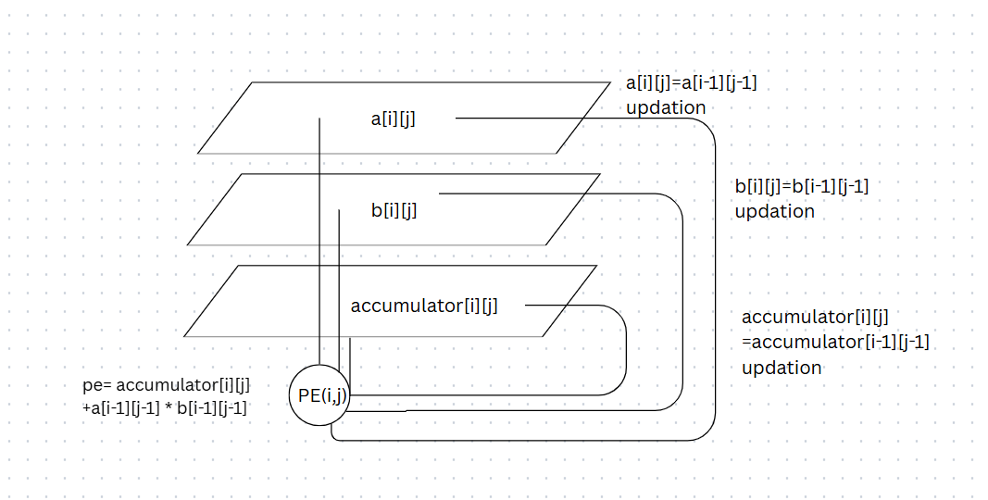
Opcode-Based Execution
Instruction execution is controlled using a case-based opcode selection structure implemented in Verilog. Based on the 4-bit opcode, the corresponding execution module is activated and its output is routed to the final 32-bit output register (cout). This modular architecture enables scalability and easy integration of additional ML operations in future versions of the accelerator.
Potential Applications
- Edge AI devices
- Computer vision systems
- Smart surveillance
- Robotics and autonomous systems
- IoT-based intelligent sensing
- Wearable AI devices
- Embedded neural-network inference
- Real-time signal and image processing
The systolic-array-based architecture enables efficient matrix computation while minimizing memory-access overhead, making the design suitable for low-power ASIC implementations.

Timing diagram for execution block:
1. The `execute_top` module acts as the centralized execution stage of the accelerator pipeline, interfacing fetch/decode outputs with arithmetic, neural-network, and matrix-computation hardware blocks through opcode-driven control.
2. The architecture integrates multiple AI-oriented compute units including MAC, dot-product, activation functions (ReLU, Sigmoid, Tanh), BNN operations, scaling, clipping, and ArgMax within a unified parallel execution framework.
3. Dedicated hardware accelerators for conventional 4×4 matrix multiplication and systolic-array-based multiplication are selectively enabled using control signals (`valid_mat`, `en_sys`) to support heterogeneous computation modes.
4. A hierarchical timing scheme is implemented using `clk` for internal accelerator operation and a slower `bigclk` for pipeline-stage synchronization, enabling controlled execution latency and simplified inter-stage data transfer.
5. The design supports pipelined processor integration by forwarding register addresses and control signals across stages, allowing seamless connection between fetch/decode, execute, and writeback modules in a modular AI accelerator datapath.
* The accelerator uses a dual-clock timing scheme where `clk` controls internal computations and `bigclk` synchronizes pipeline-stage execution.
* Input matrices are diagonally skewed through `a_pad` and `b_pad` registers to ensure synchronized operand arrival across the systolic array.
* During each clock cycle, operands propagate horizontally and vertically between Processing Elements (PEs) using `a_wire` and `b_wire` interconnects.
* Partial sums are accumulated recursively through the `accumulator → acc_next` feedback path, enabling pipelined MAC computation.
* Control signals such as `valid_mat`, `en_sys`, `done_mat`, and `done_sys` manage accelerator enable, pipeline flushing, and output-valid timing before writeback.
mat_A=[ 0 1 2 3
1 2 3 4
2 3 4 5
5 6 7 8]
Mat_B= [1 2 3 4
5 6 7 8
9 10 11 12
13 14 15 16]
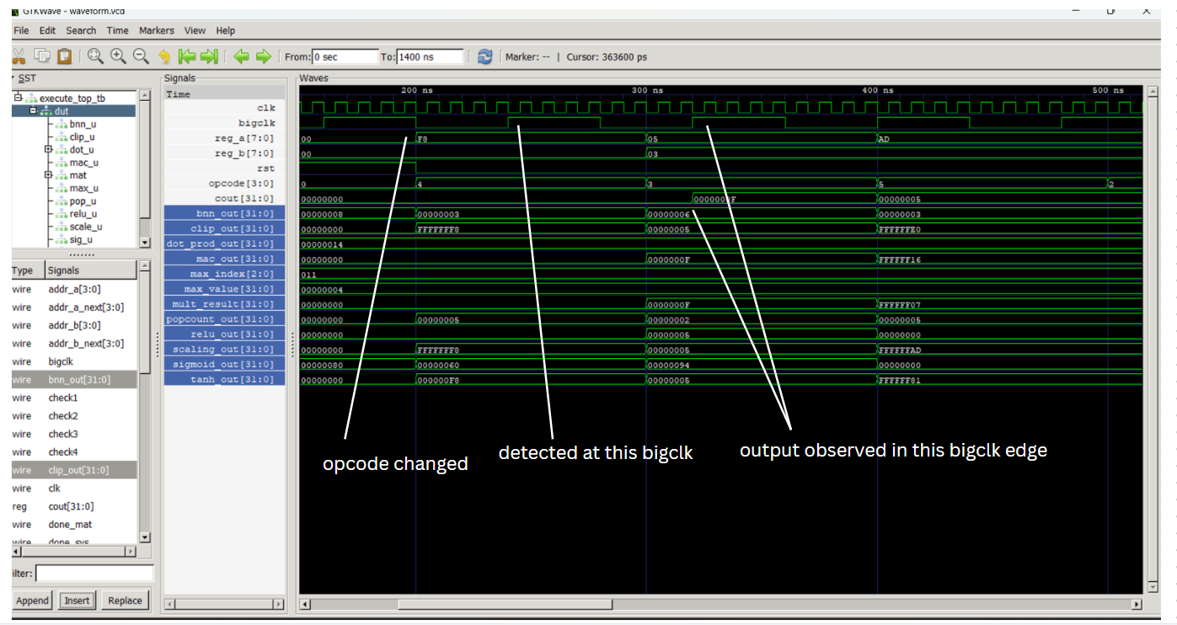
For different opcodes:
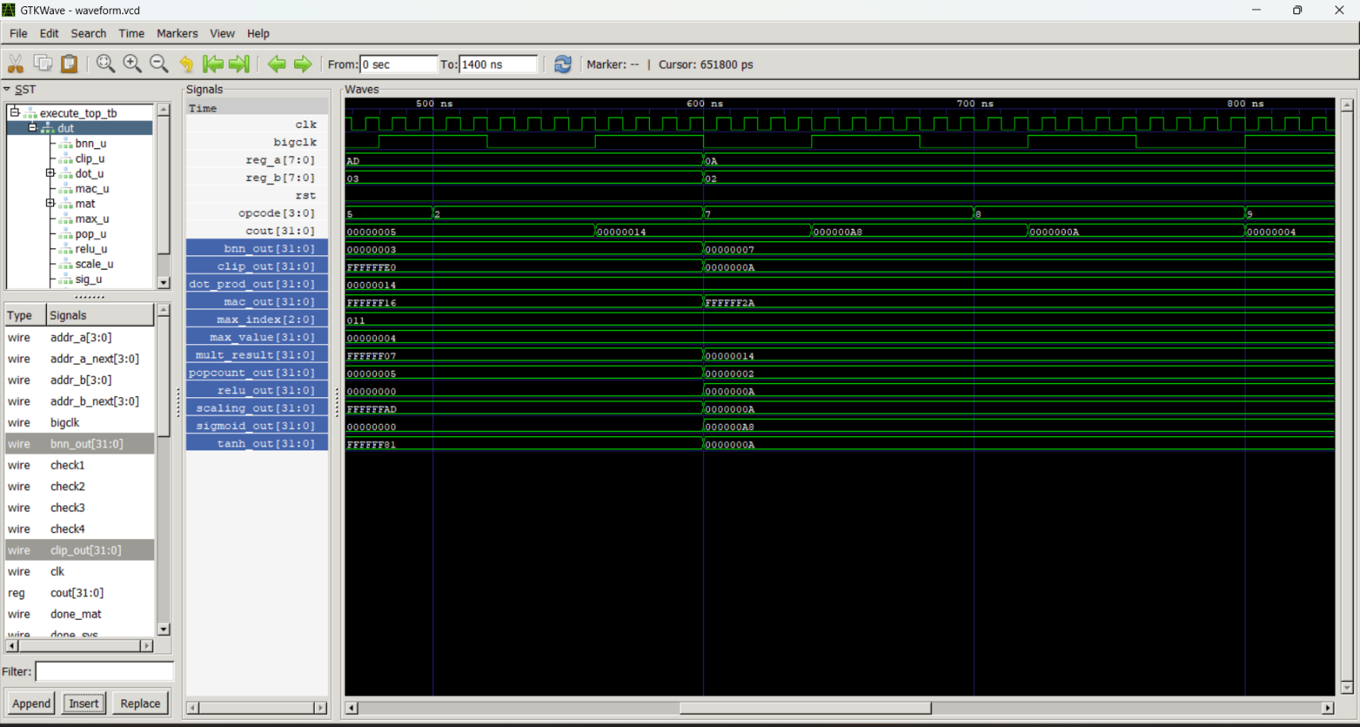

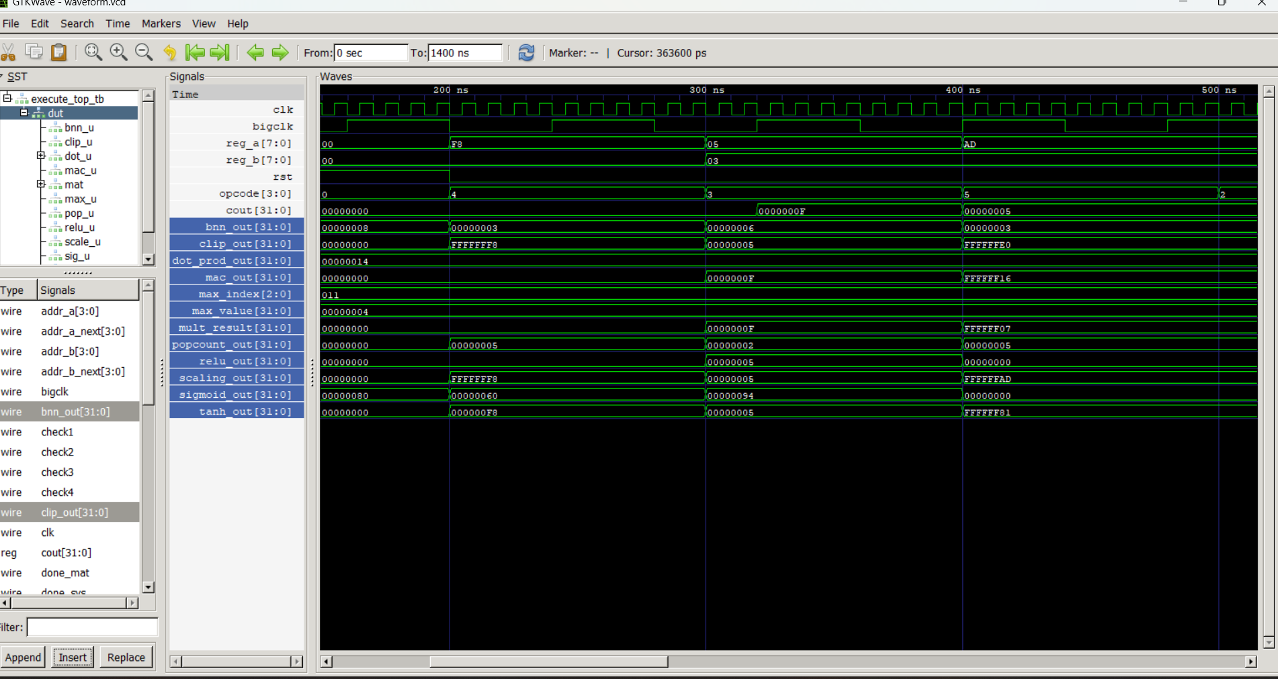

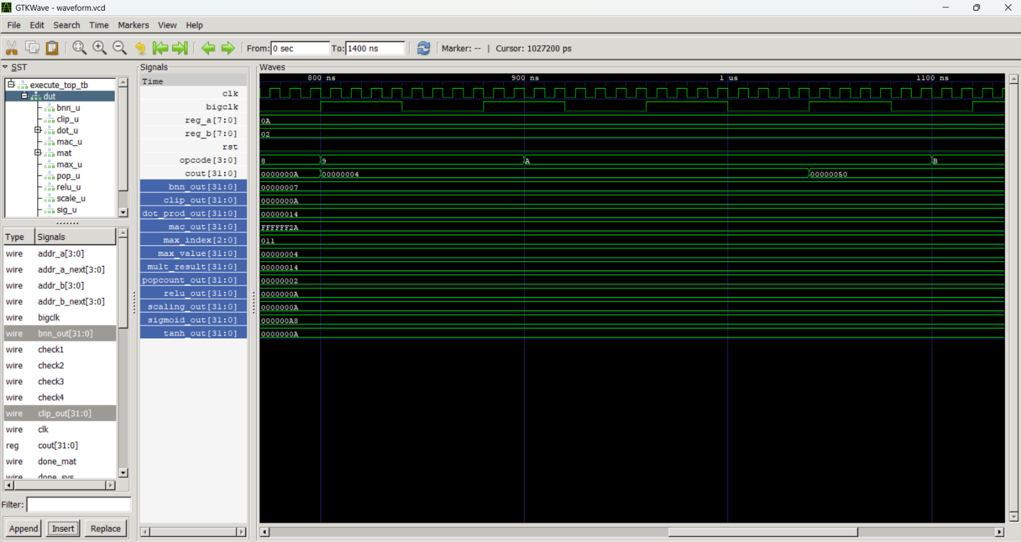

For matrix_mult:
- The matrix_mult_4x4 module implements a parallel 4×4 matrix multiplication architecture using 16 concurrent dot_product_4 computation units for high throughput operation.
- An FSM-based control path manages data loading, transpose generation, computation triggering, result storage, and completion signaling across multiple pipeline stages.
- Matrix B is internally transposed to improve row-column data access efficiency, enabling simultaneous dot-product evaluation for all output elements.
- The design uses staged valid-control signals (stage1_done, stage2_valid, done) to synchronize pipeline execution and ensure deterministic timing behavior during hardware acceleration.
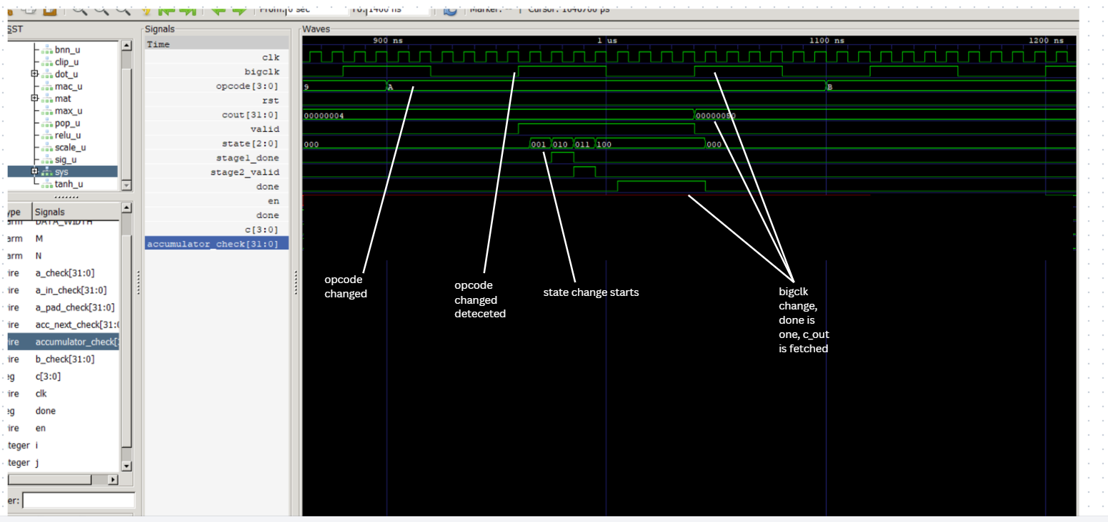

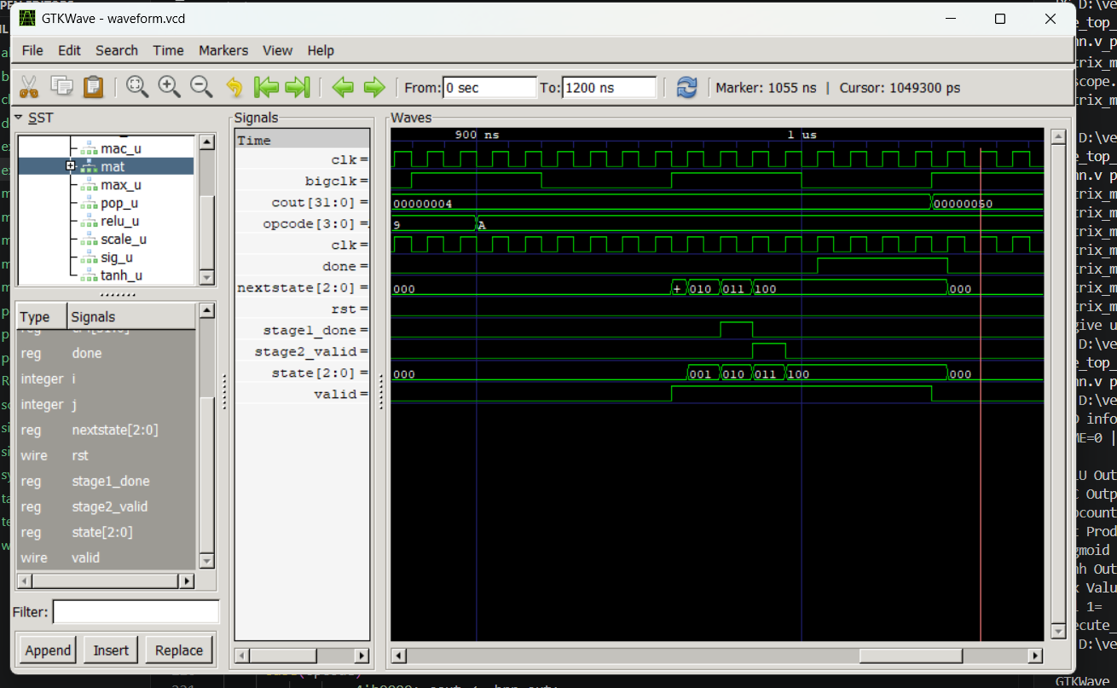

Systolic :
The accelerator implements a diagonally skewed data-injection scheme using padded shift registers (a_pad and b_pad) to guarantee cycle-accurate operand alignment across the systolic fabric without requiring complex control routing.The accelerator uses a scalable 8×8 systolic-array architecture with diagonally skewed data injection, pipelined MAC-based distributed accumulation, and operand forwarding for temporal data reuse, while a lightweight counter-driven timing scheme handles synchronization and result generation without centralized FSM control. Matrix tilling id done by processor
A lightweight cycle-driven control mechanism using the internal counter c manages operand streaming, synchronization, pipeline flushing, and result-valid timing, eliminating the need for a centralized FSM-based scheduler.
